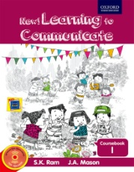
JSS SHRI MANJUNATHESHWARA CENTRAL SCHOOL, VIDYAGIRI DHARWAD
SUBJECT: ENGLISH LESSON PLAN 2020-21 CLASS: I
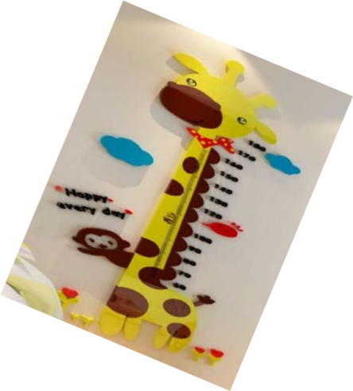
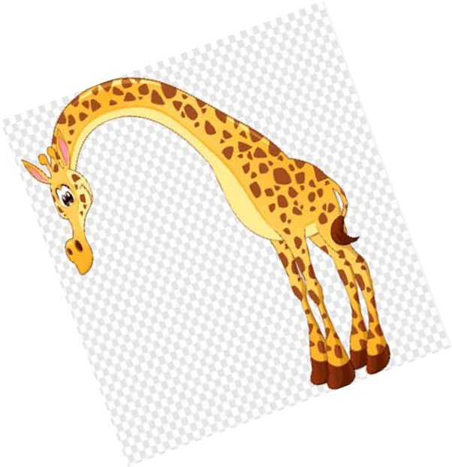
Poem 1: O Giraffe, Giraffe

Month | June
Name of the Lesson | O. GIRAFFE, GIRAFFE
No of Periods | 3
Objective | The objective of the poem is to make the children understand about the animal Giraffe.
Learning Outcome | Upon completion of this lesson, students will be able to:  - outline key facts about giraffes  - compare the size of a giraffe to that of a human  - list the habitat and diet of giraffes
Content | Poem on Giraffe*  Hard words, Word drill, Question & answers  *Rhyming words

Pre requisite knowledge | Asked children to talk about the zoo they have visited and told about the animals they saw in the zoo . Children started to discuss about the animal they saw like tiger , snake, elephant . peacock etc.
Transaction Methodology  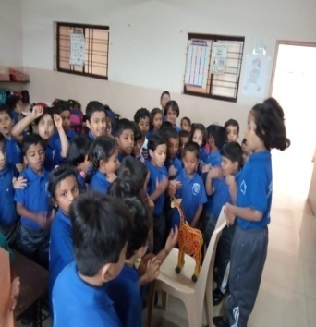 | Reading:  Each & every student is made to read a paragraph each  *word meanings are discussed Explanation:  Using simple words and simple language, the poem is explained with action to children.  Over and interaction with students: Discussed about animal they saw in zoo
Activity/Tool | Materials  - Paper copies of the text lesson Giraffe Lesson for Kids: Facts & Habitat  - Tape measure  - Duct tape  - A world globe  - A worksheet created using the quiz associated with the lesson  - White drawing paper  - Crayons
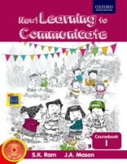  Resources | - Text book.  Online Jigsaw Puzzle > Giraffe > Skills: Problem solving, Letter G Giraffe printable activities
Assessment Strategy | - Expression and rhyme. Draw and colour Giraffe.  - Recite poem with action
Can be integrated with other subjects? How? | 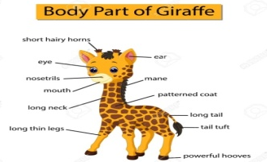  - Science  - Animals  - Parts of body
 | Life skill >Helping the animals and birds who are in trouble.
Art Integration | Recited the poem with action and draw the picture of giraffe

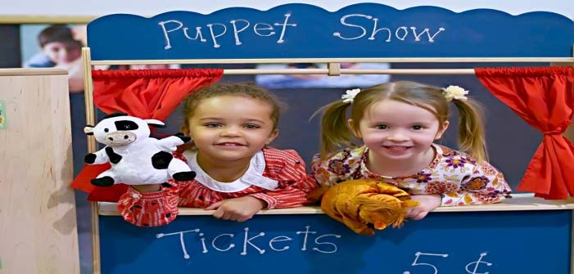
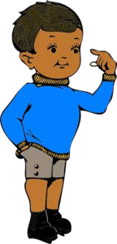

Lesson 1: Two Stories

Month | June
Name of the Lesson | TWO STORIES
No of Periods | 8
Objective | The objective of the lesson is to increase the vocabulary of the children by introducing naming words, “be” form of verb.
Learning Outcome | Child will be able to develop :  - Pronounciation: The students learn to read the lesson and comprehend. They learn pronounciation of words.  - Reading Skill: As they read the lesson, they under line the noun.  - Creative Writing: Student are made to draw their favourite fruits .  - Spellings: They learn different spellings along with their meanings.  - Vocabulary: New words are given to enrich their vocabulary. (Baobab, botanist, pitcher)  Writing – completing Q and A statement
Content | - Introduction of the lesson - Two Stories.  - Conversation between the children about a particular topic  - Grammar – naming words , 'This' and 'That' - Teach by using objectives  - Interaction with children about their first day in the school

Pre requisite knowledge | Showed the children a paper flowers and asked Shall we put it in the water? Helped children to reziled that is not real . Ask :’are you surprised ?  Showed them a tiffin box. Ask ‘What ‘s inside?  The children suggest different types of food .Ask a child to open the box inside is a familiar object – a whistle or a key .  Children were surprised .
Transaction Methodology | Reading:  Each & every student is made to read a paragraph each  *word meanings are discussed Explanation:  Using simple words and simple language, the lesson is explained with roll play to children.  Over and interaction with students: Discussed about fruits,  What was the apple made up of ?
Activity/Tool | - Using puppet show mud apple empty box craft of frogs
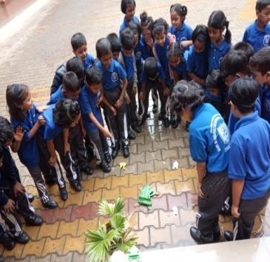  Resources | - Text book.  Stories for Kids  www.freechildrenstories.com  Slide shows of conversation Text book:  New learning to communicate ( course book)
Assessment Strategy | Answer the questions., work sheet spell back word. Making of frog by using craft paper.
Can be integrated with other subjects? How? | Science – animals,- frog – shape- size- colour  - fruits - making them the understand that – an apple a day keeps a doctor away
Art Integration | - Student played a roll play and a game - hopping like frog

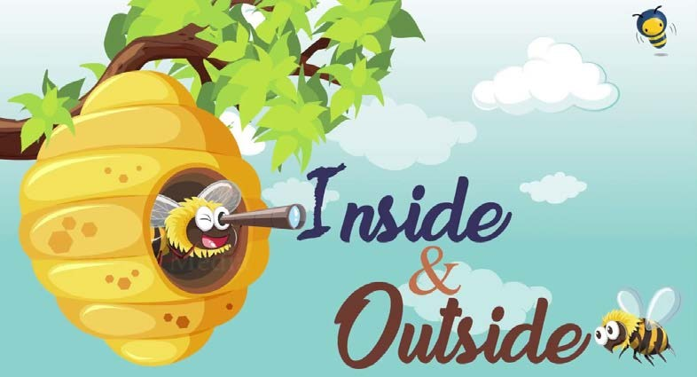
Lesson 2: Inside and Outside

Month | June
Name of the Lesson | Inside and Outside
No of Periods | 8
Objective | The objective of the lesson is to introduce forms of nouns and pronouns (singular/ plural).
Learning Outcome | Child will be able to develop :  - Listening skills conversion singular and plural  - Factual and Inferential reading skills  - Vocabulary framing question  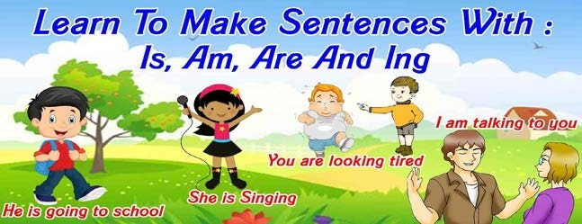  - Grammar- using of is and are, use of I am and you are  - The ability to complete questions and statements  - The ability to frame questions
Content | - Reading : Factual inferential  - Communication Shills: Word game and conversion singular and plural  - Speech practice :phonic practice  - Grammar one and more then one ,Use of is and are , use of Iam and You are  - Vocabulary : Picking the odd one out and things used every day.

Pre requisite knowledge | Asked children to name the things that they ee in the class room  Children stated to tell black board . duster, chalk . teacher , etc.  Now name the things that you can see outside . pot . charts ect
Transaction Methodology | Reading:  Each & every student is made to read the lesson  *word meanings are discussed to enable all students to ingest the said matter correctly and in the correct sense.  Explanation:  Using simple words and simple language, the lesson is explained to children  Children were asked to collect the things which were inside the classroom and out side the classroom . and name them  Over and interaction with students:  - Does Karan likes bees ?  Is honey sweet or salty?
Activity/Tool | making children to play indoor and outdoor games  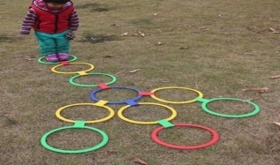
Resources | Text book:  New learning to communicate ( course book)
Assessment Strategy | - Answer the questions  - cross words puzzle  name some out door and in door games
Can be integrated with other subjects? How? | Maths , and outside and inside chapter  Naming the object which are inside and outside.
Art Integration | Student played games of in and out

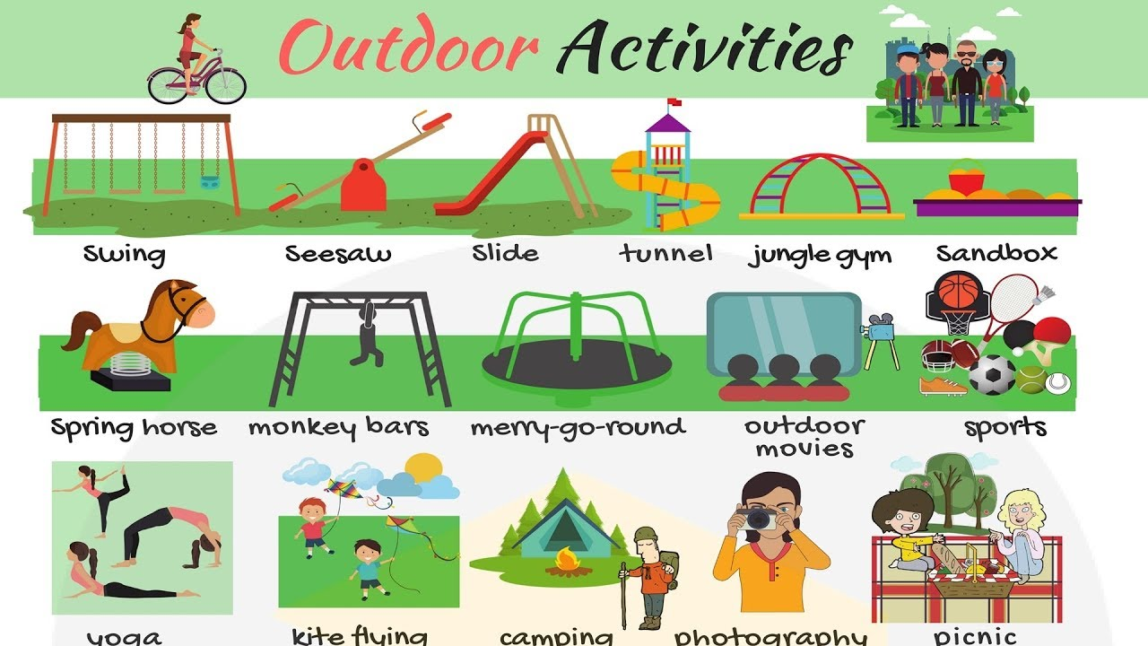
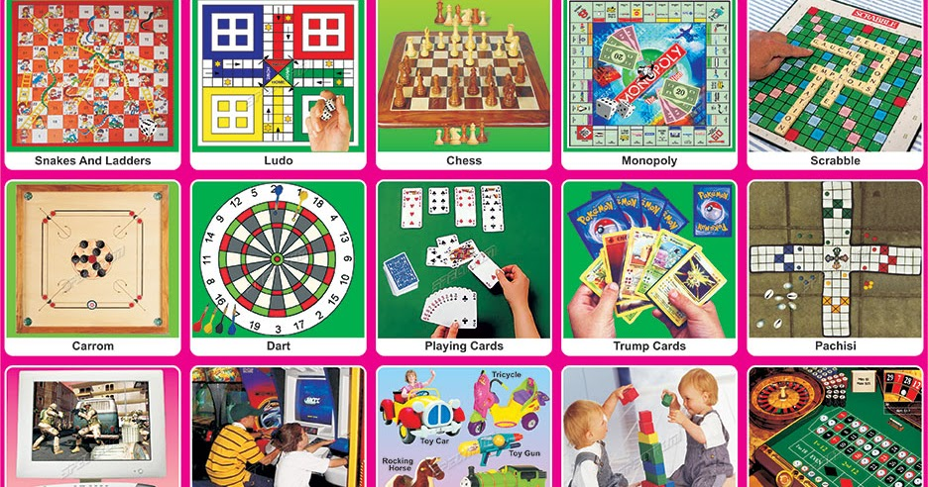
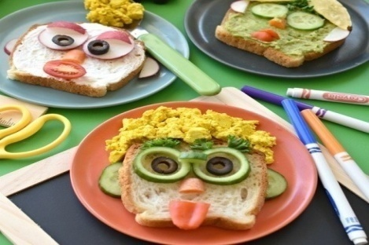

Lesson 3: My Breakfast

Month | August
Name of the Lesson | My Breakfast It has been said that breakfast is the most important meal of the day. Teach your students about the history and value of a good food for human being and Animals too  My Name is Bingo
No of Periods | 4
Objective | After completion of this lesson, students will be able to identify context clues within a text to define unknown words or phrases in informational text by combining their background knowledge with textual evidence.  The objective of the lesson is to increase their writing and recollecting bility
Learning Outcome  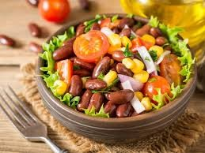 | Upon completion of this lesson, students will be able to:  - summarize the origins of breakfast  - explain the value of a healthy breakfast  - list and describe common breakfast foods from around the world  - discuss healthy breakfast options
Content | - Reading : Factual inferential  - Communication Shills: Recalling information ,asking and answering question  - Speech practice :phonic practice  - Grammar : use of have and has ( to eat/drink)  - Vocabulary : Food  Writing : completing sentences using words given

Pre requisite knowledge | Asked children about their favorite food and breakfast.  They stated to responses with different types of food and breakfast .  And told about my favorite food too .  Do you have pets at home ?  Asked do pet also eat breakfast ?
Transaction Methodology | - begin the lesson by having the students sit and gather around you near a comfortable spot in the classroom.  - Explain that over the weekend, your family had breakfast without you because you decided to sleep in.  - Tell them that breakfast is your favorite family time and that you wish you could have shared that special moment with them.  Bring out the mystery breakfast trash bag and explain that even though you weren't able to see what they had for breakfast that you still think you can figure it out by checking the contents of the trash bag from that day.
Activity/Tool | 1 - Explanation about the Lesson a) Loud reading pg 31  b) Hard words Pg 31 c) Exercise Pg 32  - - Class room activity by children - Pair work Exercise Pg 33  - - Activity by children  - - Introduction of 'Has' and ' Have' Exercise pg 34 5 - Exercise Pg. 35
Resources | - Text book.  New learning to communicate ( course book)
Assessment Strategy | - Spell bee words  - Taken the last 10 minutes of class to have the students exchange of their Tiffin. With their friends  - Reading text book.
Can be integrated with other subjects? How? | Science.  - Teaching the importance of nutrition and staying healthy
Art Integration | Roll play on cooking like delicious food. ( with their playing kitchen set

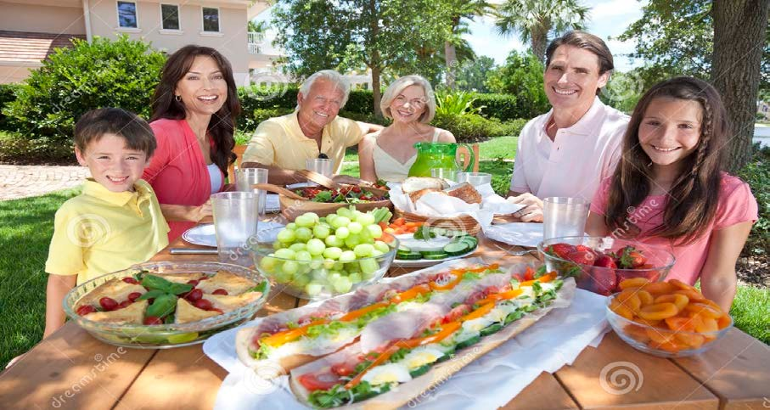

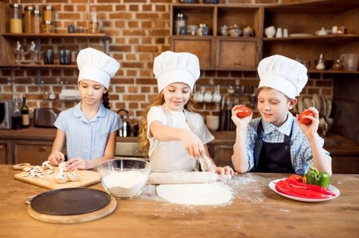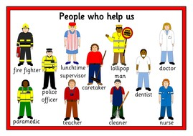

Lesson 4: About People

Month | August
Name of the Lesson | About People
No of Periods | 6
Objective | The objective of the lesson is to increase their writing and recollecting bility Building a sense of community fosters dependability and citizenship. Help students become aware of people in the community who assist them daily.  Children will be given time period to talk about the people.  Teacher will explain the usage of question words using Who And What. Making children to learn the topic using smart board.
Learning Outcome | Students will be able to identify different important members of a community.  - Ask the students about the people in their neighbourhood, aside from family members.  - Take responses from volunteers.  - Tell the students that today, they're going to learn about the people in a community
Content | - Reading : Factual, Inferential  - Listing and speaking: taking about people who helps us and the job they do. And roll play : profession  - Phonic practice. Using contraction for is.  Grammar: use of Who and what (question tag)  use of He and She (pronoun)

Pre requisite knowledge | Ask, What’s my name?  What work I do?  What’s the name of the principal?
Transaction Methodology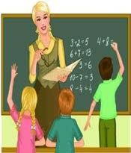 | Talked about the people who children know in the school and the work they do.  Began with the lesson by asking the children about the occupation of their parents.  Discussed about the people who flew the filghts, protectors, tailors and chefs.
Activity/Tool | Provide each student with the worksheet Who Am I? Read the instructions to the students. Read each sentence to the students, and let them select the appropriate answers. Allow the students to color the community helpers. Collect the papers for grading.  - Pictures of a librarian, cashier, teacher, mail carrier, doctor, and trash truck driver Who Am I worksheet Jobs People Do by Jo Litchfield and Felicity
Resources | - Flash card s  - Text book ( new learning to communicate )
Assessment Strategy | Show the students a picture of a librarian, a cashier, a teacher, a mail carrier, a doctor, and a trash truck driver. Ask the students what each person does. Take responses from volunteers. Ask the students about other people in a community who help everyday. Make a list on the board of their response  Review students' work to assess their understanding of the lesson. Give reinforcement where needed
Can be integrated with other subjects? How? | EVS  PEOPLE SERVE FOR US  - WORK DONE BY DIFFERENT PEOPLE.
Art Integration | various role of our daily life  Children will be given time period to talk about the people  Teacher will explain the usage of question words using Who And  What  .Making children to learn the topic using smart board  Roll play on PEOPLE WHO WORKS FOR US . EX. DOCTOR ,TEACHER ,POSTMAN ECT

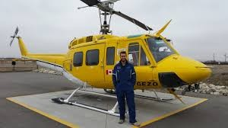

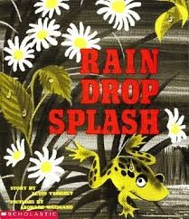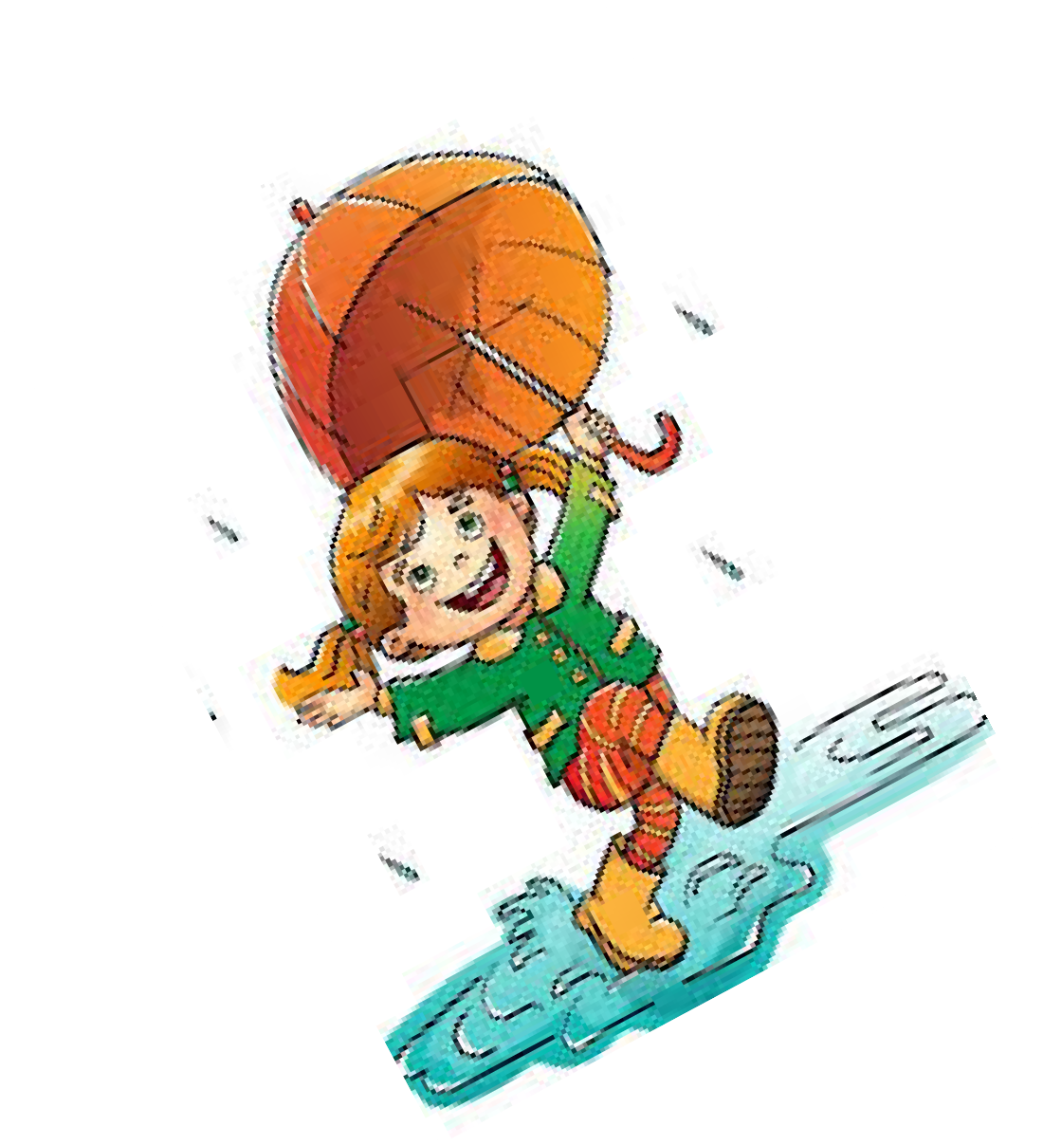
Poem -Splash

Month | August
Name of the Lesson | Poem : Splash
No of Periods | 3
Objective | The objective of the poem is to make the children understand about the Manson
Learning Outcome | The children will participate in reading familiar words rhymes They will sing and perform songs to the class
Content | Hard words, Word drill,  *Rhyming words

Pre requisite knowledge | Activities of children during rainy season, the type of clothes they wear, the food that they eat.
Transaction Methodology | Discussed about the rhymes that they have lent in the previous class “rain rain go away come again another day ‘  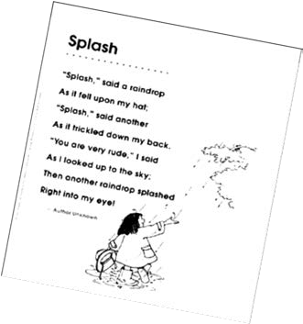  The teacher reads out the poem to the class with correct pronunciation paying attention to rhythm and meanings. And recite the poem
Activity/Tool | Text book  - Ppt of raindrops.
Resources | - http://www.balloonandben.com/
Assessment Strategy | Draw a rainbow and colour it  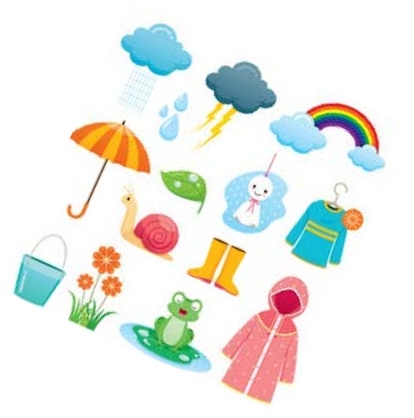
Can be integrated with other subjects? How? | Evs Manson  Clothes we wear in different Manson
Art Integration | Recited the poem with action and draw the picture of rainy day  And colour  .

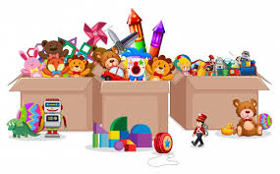

Lesson 5: We are Toys

Month | August
Name of the Chapter | We Are Toys
No of Periods | 10
Objective | Children will be able to identify some toys as well as count and describe them using colours.
Learning Outcome | Upon completion of this lesson:  - Children will have Phonic (speech) Practice  - Identify different animal toys and the sounds they make.  - Recognize the size, colour and the material the toys are made of.
Content | - Introduction to the lesson  - Using “can”.  - Singular and Plural  - Using the article “a”.  - Is, am and are.  - Capital Letters.
Pre requisite Knowledge | Children were asked about different kind of toys they play with.
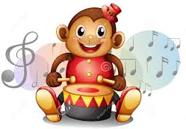  Transaction Technology | - Introduce the lesson by providing toy flash cards to children.  - Fun Game :” Hide and Find” ,can be played in the class.  - Hide the toy flash cards in the classroom and children will search for them.
Activity/Tool | - Explanation about the lesson  - Loud reading Page No: 48 b) Hard words page no: 48 c) Exercise Page No: 49 and 50.
Resources | - English Text Book (course book)  - Toy Flash Cards  - https://images.app.goo.gl/zZyy9XGAior6Q6
Assessment Strategy | - Answer to the question  - Writing the sentences  - Different Punctuation marks in a sentence
Can be Integrated with other subjects? How? | - Maths- Size, Shape of the toys
Art Integration | Children played fun game: “Hide and Find”

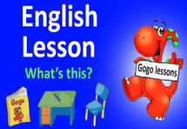
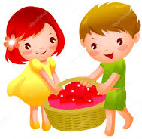

Lesson 6: What’s This?
Month | August
Name of the Chapter | What’s This?
No of Periods | 12
Objective | The objective of the lesson is to teach children about Framing questions.
Learning Outcome | Child will be able to:  - Communication Skills- Asking and answering questions  - Spellings-Student learn different words  - Reading Skill-Children will read the lesson and underline the nouns and pronouns.
Content | - Explanation about the Lesson- What’s This?  - Children will learn to frame question
Pre requisite Knowledge | Each Student was asked to frame different kind of questions.
Transaction Technology | - Reading : Students will read the lesson.  - Explanation: Showing different things in the classroom the lesson will be introduced by asking questions about it.  - Interaction with students: Answer will be told and children must frame the questions.
Activity/Tool | 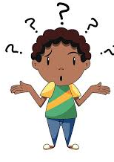  - Children will participate in group discussion about asking the questions with their friends.  - Contractions: What’s , it’s  - Jumbled words.
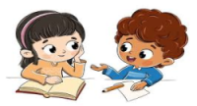  Resources | - English Text Book.  - https://www.youtube.com/watch?v=hDx1i9JJEO0
Assessment Strategy | - Spell Bee Words  - Dialogue completion  - Reading Text Books
Can be Integrated with other subjects? How? | Maths- Counting the number of things like sweets, fruits, animals etc.
Art Integration | Conversation practice was given to students.
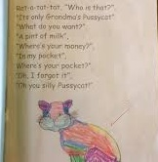
Poem: Oh, You Silly Pussy Cat!

Month | October
Name of the Chapter | Oh, You Silly Pussy Cat!
No of Periods | 3
Pre requisite knowledge | A rhyme or song will be shared by children in a rhythmic way.
Objective | The main objective of the poem is to teach the dialogue participation in a poetic way
Learning Outcome | On completion of this poem, children will be able to  - Outline few facts about the Pussy cat  - Sing the rhyme all the way through with the children until most of them are familiar with the words.
Content | - Rhyming words  - Dialogue participation
Pre requisite Knowledge | Students elaborated about the characteristics of various pet animals.
Transaction Technology | Reading:  Every child is made to read the poem.  - Word meanings will be discussed.  - A simple language is used to elaborate the poem.
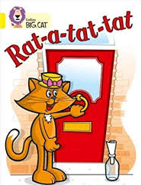  Activity/Tool | - Children will create decorative photo book of the poem using the characters of cat and rat .  Materials:  - Coloured paper sheets.  - Crayons  - Glue  - Duct tape
Resources | - https://www.mamalisa.com/?t=es&p=5135  - https://www.youtube.com/watch?v=WS21evPa0C4
Assessment Strategy | - Recite the poem with actions  - Draw and colour cat and rat.
Can be Integrated with other subjects? How? | Science  - Parts of Body  - Animals  - Life Skill: Caring and helping the needy animals
Art Integration | Recitation of poem in a rhythmic way with actions.

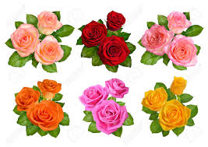
Lesson 7: What Colour Is It?

Month | 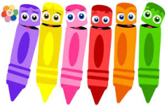  October
Name of the Chapter | What Colour Is It?
No of Periods | 7
Objective | - To teach the children about recognizing the different colours.
Learning Outcome  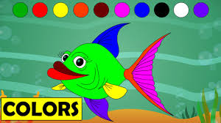 | Children will be able to:  - Identify different colours.  - Factual and Inferential reading skills.  - Vocabulary : Cross words, Writing Riddles
Content | - Rhyming words with colours  - Phonic Practice  - Special names  - Completing phrases  - Telling the time
Pre requisite Knowledge | Each child was asked to recognize different colours
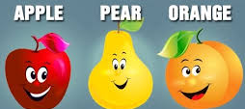  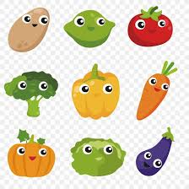  Transaction Technology | - Ask, which colour is it?  - What is the colour of different things like: Flowers, Fruits, Vegetables etc….
Activity/Tool 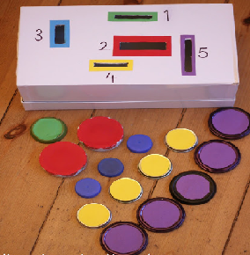 | Fun Game: “Colour sort and Posting Box”  - Children must choose the specific colour and post them in the respective coloured box
Resources | - https://theimaginationtree.com/20-colour-activities-for-preschoolers/  - English Text Book (course book)

Assessment Strategy | - Show the students pictures of vegetables, fruits, flowers, black board, desk and children will tell the colours of that particular thing.  - Review students answers to know their understanding about the lesson
Can be Integrated with other subjects? How? | EVS: Identifying the colours of fruits, tress, flowers, cereals.
Art Integration | Students played a fun game about identifying different colours.
Assessment Strategy | - Show the students pictures of vegetables, fruits, flowers, black board, desk and children will tell the colours of that particular thing.  - Review students answers to know their understanding about the lesson
Can be Integrated with other subjects? How? | EVS: Identifying the colours of fruits, tress, flowers, cereals.
Art Integration | Students played a fun game about identifying different colours.

Lesson 8: Hot and Cold

Month | October
Name of the Chapter | Hot and Cold
No of Periods | 7
Objective | The students will be able to describe the meanings of the words "Hot" and "Cold" with words, pictures or writing
Learning Outcome | Children understand about the seasons like Summer, Monsoon and Winter
Content | Child will be able to:  - Listening skill: Responding to the given question.  - Speech Practice: Possessives, Phonic Practice  - Vocabulary: Opposites
Pre requisite Knowledge | Students will recognize the objects whether it is hot or cold.
Transaction Technology | - Word meanings are discussed in the class  - Verbs: Describing words  - Cross Words: a word tree
Activity/Tool | Fun Game: “ Put the Mitten On”  Children will sit in a circle with their group. Deposit one mitten in front of each child. Show your group a picture (Open picture game-Hot and cold) If the picture represents cold, children must put the mitten on. If the picture represents hot, children must leave the mitten on the floor.
Resources | - https://www.educatall.com/page/630/Hot-and-cold.html  - https://karacarrero.com/teaching-hot-and-cold/
Assessment Strategy | - Answer the questions  - Name some Hot and Cold things or objects  - Spell Bee words
Can be Integrated with other subjects? How? | Science: Teaching about the different climatic conditions
Art Integration | - Fun Game: “ Put the Mitten On”  - Worksheets about opposite words.
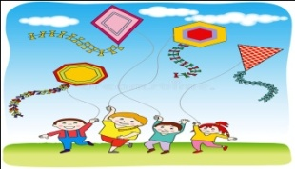
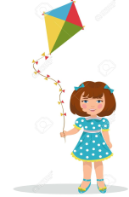
Lesson: 9 NANCY HAS A YELLOW KITE

Month | November
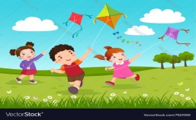  Name of the chapter | Nancy has a yellow kite
Number of periods | 7
Objectives | Objectives of this lesson  *Introduction of articles,Present continuous tense,has and have  *Children learn to spend their leisure time in nature.
Leaning out come | Children were be able to understand  * Reading skill: As they read lesson they underline nouns and articles  *Spellings : children learn meanings of words in the lesson.  * Group discussion : they discuss about colours.
Content | * Reading: Factual, inferential  * Grammar: Use of Articles, Has and Have  * Conversation between the children about colours
Pre requisite knowledge | Children were asked  *Have you ever flown a kite ?  *How many of you go to park to fly kite?  * who helps you to fly a kite ?
Transaction Methodology | *Reading  Students are made to read each line,words meanings are discussed  *Explanation  Using simple words the lesson is explained like a story.
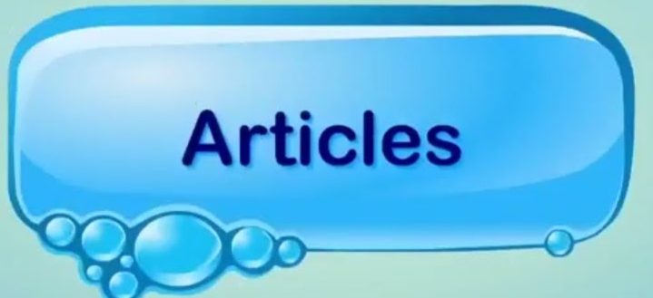Activity /Tool | *Role play in a toy shop,a toy shop was set up in the class room and conversation between children and teachers is done.  *Flash cards articles will be given to children to piace the suitable articles before vowels.  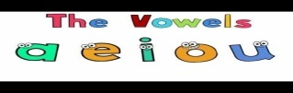
Resources | *Text book  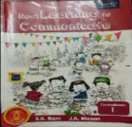  New learning to communicate.
Assesment Strategy | *Answer the Question, Work sheet  *Cross word
Can be integrated with other subject | *Science with colours
Art integration | *Children were asked to make kites with colour papers.

Poem: 4 Q Is a Funny Letter

Month | November
Name of the poem | Q IS A FUNNY LETTER
Number of periods | 3
Objectives | *The objective of this poem is to make children understand the importance of letter Q.
Leaning out come | Children were be able to understand  *Children will recite the poem with action  * Children will list the words starting with letter Q.
Content | *Poem Q is a funny letter
Pre requisite knowledge | *Phonic sounds of English letters
Transaction Methodology | *Reading  Poem is recited with action  *Explanation  Poem is explained with simple language with actions
Activity/ tool | *Materials  Worksheet created using the words Q in the poem  White paper, colour pencils.  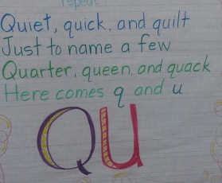
Resources | 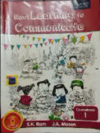  *Text book
Assesment Strategy | *Recite the poem with action
Can be integrated with other subject | Can be integrated with science aquatic bird  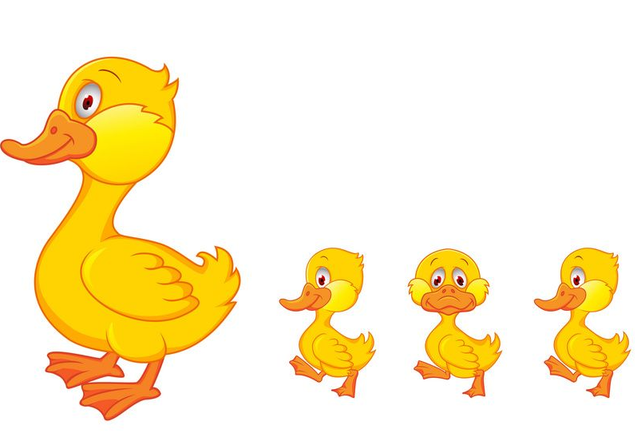Duck that sound like letter Q
Art integration | Children were asked to draw and colour letter Q creatively.

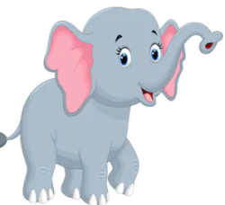

LESSON 10 -The House is Shaking

Month | December
Name of the lesson | The house is shaking
Number of periods | 7
Objectives | Objective of this lesson  *To be brave and not to get panic during wild animal attack  *to increase awareness of different sounds in forest.
Leaning out come | Children were able to understand  *Listening skill : following instructions  *Grammar : Special names, Present continuous tense  *Writing skill : Completing sentences in a story.
Content | Grammar: Special names, is or are and Present continuous tense.  Pick out the odd word from each group.
Pre requisite knowledge | Asking children  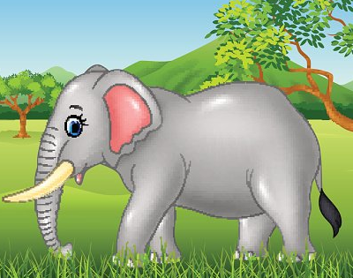What features of elephant can they see?
Transaction Methodology | *Reading  Students are made to repeat each line in the lesson.  *Explanation  In simple language lesson is explained.
Activity/ tool | Pet show  Pet show wearing animal masks then talk about your favorite animal, its food, its home, the noise it makes
Resources | 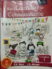  English text book New learning to communicate.  https://www.youtube.com/watch?v=QiKxHEWjQxo
Assesment Strategy | List and collect the pictures of wild animals.  Answer the question,hard words and meaning.
Can be integrated with other subject | 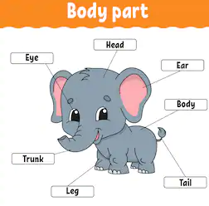Can be integrated with Science subject
Art integration | Make masks of animal using paper bag and paper plates.

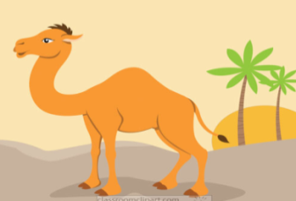
LESSON 11-I am the ship of the desert

Month | December
Name of the lesson | I am the ship of the desert
Number of periods | 7
Objectives | Objective of this lesson  *Introduction of preposition words,opposite words  *to put a fullstop(.) or a question mark(?) at the end of sentence.
Leaning out come | Children were able to understand  *How animals are adapted to different regions  * About desert,plants grown in desert and hot sand.
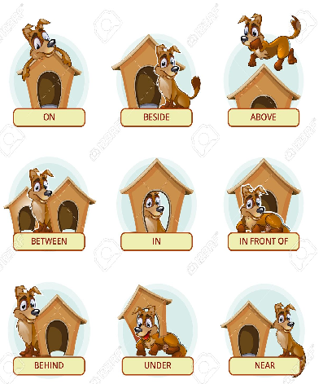Content | Grammar :  * Prepositions use of in, on under and behind  * Opposite words ,pair work  * full stop and question mark.  *Conversation between lion and camel
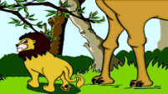  Pre requisite knowledge | Discussing with children and asking them  Have you ever seen a desert?  Have you ever seen a camel?  Why can’t lion live in desert?
Transaction Methodology | Group discussion was conducted .topic  *Mode of transport in desert .  *weather conditions in desert  *why cant we grow all kind of plants in desert?
Activity/ tool | Sand Art  *Children were asked to draw their favorite picture, apply  glue on that and sprinkle sand on the picture.
Resources | English text book New learning to communicate  https://www.youtube.com/watch?v=_VK-kXkXTBc
Assessment Strategy | Asking Hard words, Meanings and Question and answers.
Can be integrated with other subject | 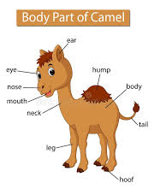  Science  Animals : Parts of  body
Art integration | Collect pictures of desert plants and animals and do collage work.

END

