JSS SHRI MANJUNATHESHWARA CENTRAL SCHOOL-DHARWAD
Lesson plan 2020-21

Std- 1 Subject- Mathematics.
CHAPTER 1 Spatial understanding

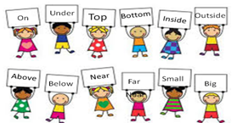

Month | June
Chapter | Spatial understanding
Periods | 10
Content | 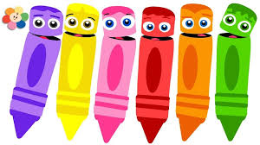  1. Top – Bottom  2. On – Under  3. Inside – Outside  4. Above – Below  5. Near – Far  6. Small – Big  7. Less – More  8. Before, after and between.
Pre-requisite (KNOWLEDGE) | Few basic questions will be asked to know the previous knowledge of children, like  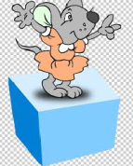  - Where is your bag?  - Where are you sitting?  Like this, the concept will be introduced.
Transaction Methodology | Students will be told to refer the text book and teacher will explain each concept (position of things with examples).  Children will be asked questions for looking for the position of their belongings (ex. Book, pencil,…)  Teacher will ask the children to recollect the things which are inside and outside the house.
Activity /Tool | 1. Flash cards of positions words.  2. Look around: Pairing the children, a student could say, “This object is under the table.” The second student guesses which item his partner is describing. “Is it a bottle?” If the student gets the answer right, they switch roles.  3. Where is it? :  A student hides the object in the classroom while the other student hides their eyes. Once the student is back in his seat, his classmates ask questions using position words and try to locate the item. The person who hid the object answers their questions until someone guesses correctly. The person who guesses correctly gets to hide the item for the next round.  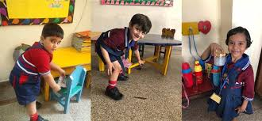  4. A Messy Room :  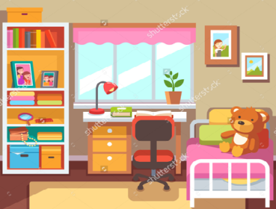  Showing students a picture of a messy room. Asking them what is wrong with the picture and where the person’s items should be. For example, if clothes are on the floor students would say, “The clothes should be IN the closet.”. If the books are on the bed students will say, “The books should be ON the study table.”
Learning Outcome | Child will be able to understand:  1. The child will able to tell the position of things.  2. Improves the vocabulary.
Resources | Textbook: Let’s Discover Mathematics(CBSE) class 1  Web link: https://www.fluentu.com/blog/educator-english/teaching-prepositions-esl/
Can be integrated with other subjects? How? | Can be integrated to English grammar prepositions.  Can be integrated to life skills-day -to-day life.
Art integration | Drawing the pictures as per the positions given below  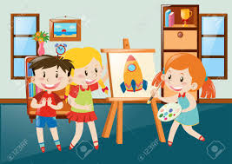  - The ball is under the table.  - The clock is on the wall.  - The shelf is above the table.  4. The rug is between the bed  and the wardrobe.
Assessment Strategy | Playing the game Simon says:  1. Put your ruler on the table.  2. Put your pen on your exercise book.  3. Put your pencil between your exercise book and your ruler.  4. Put your bag under the table.  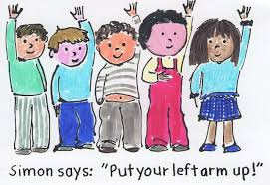

****************************

JSS SHRI MANJUNATHESHAWARA CENTRAL SCHOOL – DHARWAD
LESSON PLAN 2020-21
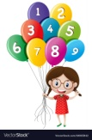
STD 1 Subject: Mathematics
Chapter 2 Number [0 to 9]

Month | July
Chapter | Numbers [ 0 to 9 ]
Periods | 8
Contents | 1. Numbers 1 to 9  2. Introducing ‘zero’ [0]  3. Before and After  4.Numbers between  5.Equal numbers  6. Comparison of numbers
Learner previous knowledge | Recognizing space, knowing numbers, Enjoying numbers by saying number rhymes.
Transaction Methodology | Brainstorm with children a list of ten or more things that are associated with fun. The list could include people, animals, or things that children enjoy. It could also include indicators that someone is having fun, such as a smiles, laughter, grins, etc. List children's responses on the board or on chart paper.
Activity tool | 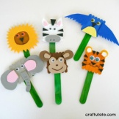  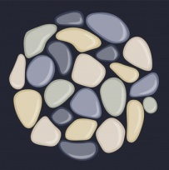  Ice-cream sticks, pebbles, books, leaves, flowers.
Learning outcome | - Children are able tell the numbers and names  - Kids are able to identify numbers by counting the picture.  - They are able tell the numbers that come after, before and between.  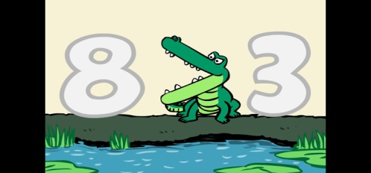  - Children are able to identify Zero concept.  - Children are able to compare the greater and smaller number.
Resources | Textbook: Let’s Discover Mathematics(CBSE) class 1  Web link  http://www.eduplace.com/rdg/gen_act/fun/book.html
Can be integrated with other subjects? How? | 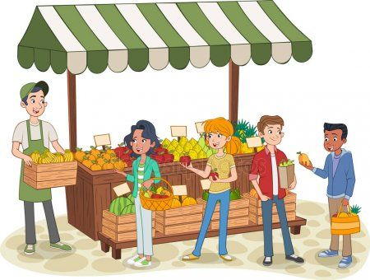  Can be integrated to day to day life skills activities.
Art integration | - Collecting the objects as per the number given.  - Compare the fruits in the fruit basket.  - Put equal number of ball in the bucket.  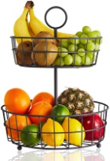
Assessment Strategy | 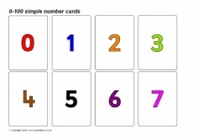  - Arrange the flash card in correct order.  2. Write the missing numbers.  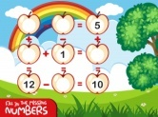  - Compare the numbers using the symbol <, >, =.  - Solve text book sums. 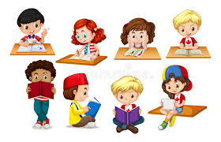

****************************

JSS SHRI MANJUNATHESHWARA CENTRAL SCHOOL-DHARWAD
Lesson plan 2020-21

Std- 1 Subject- Mathematics.
CHAPTER -3 ADDITION (0 to 9)

Month | July
Chapter | 3. ADDITION ( 0 TO 9 )
Periods | 9
Content | - One more than a number  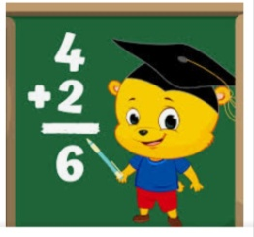  - Addition concept  - Different ways to add  - Zero property  - Order property  - Missing addend  - Addition stories
Learner’s previous knowledge | Few basic questions will be asked to know the previous knowledge of children, like  1. 2 chocolates + 2 chocolates = total how many chocolates?  2. 3 books + 4 books = how many books altogether?  Like this, the concept will be introduced.
Transaction methodology | Concept of addition is cleared.  Children will learn the new words used in addition.  Children will learn different methods of addition.  Using simple words and language the addition will be taught to them.
Activity/Tool | Teaching the children the words that signify “addition”, children will be introduced the words such as – “altogether”, “put together”, “how many in all”, “total” or “sum”. This commonly indicates a child will need to add two or more numbers.  By telling small stories based on addition, the concept of addition is made clear.  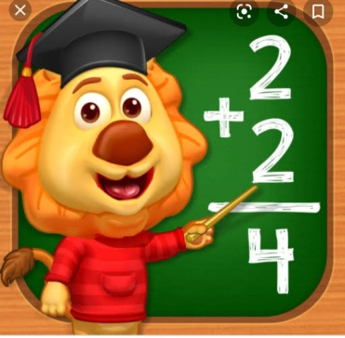
Learning Outcome | - Children will be able to add numbers 0 to 9.  - They will be able to use different method to add the given numbers.  - Children will be to tell the effect of ZERO in addition.  - They will be able to explain order property in addition. 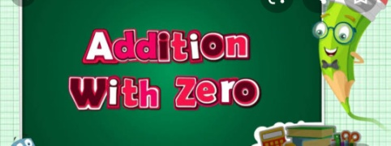
Resources | Textbook: Let’s Discover Mathematics(CBSE) class 1  Web link: study.com  Education.com  Google
Can be integrated with other subjects? How? | Yes, it is used in our day-to-day life activities, like  - In counting and adding the toys they have  - In adding their belongings  - In adding coins they have collected  - In adding flowers, fruits and vegetables, etc.
Art integration | - Children are asked to add the things kept on table in two different groups  - They will be given simple addition flash cards and asked to add them  - Using flowers, toys, pencils which are arranged in two groups addition is understood clearly.  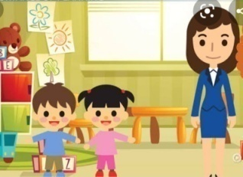
Assessment Strategy | - Children will be assessed on the basis of work sheet (having addition sums) solved by them.  - They are called to solve the addition sums written on the board.  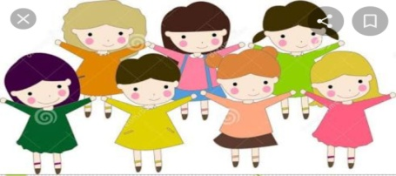

****************************

JSS SHRI MANJUNATHESHWARA CENTRAL SCHOOL-DHARWAD
Lesson plan 2020-21

Std- 1 Subject- Mathematics.
CHAPTER -4 SUBTRACTION ( 0 to 9 )
Month | August
Chapter | SUBTRACTION ( 0 TO 9 )
Periods | 8
Content | - One less than a number  - Subtraction concept  - Zero property  - Different ways to subtract  - Subtraction families  - Subtraction stories  - Equal groups
Learner’s previous knowledge | Few basic questions will be asked to know the previous knowledge of children, like  - You have 4 cakes and you will eat 2 cakes in the evening.  How many cakes left with you now?  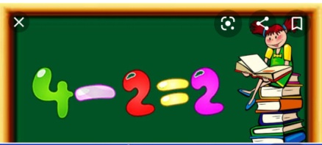  - You have 6 flowers and you lost 1 flower. Now how many flowers left with you?  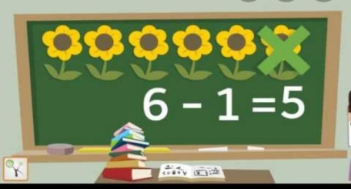  Like this, the concept will be introduced using their knowledge.
Transaction methodology | Concept of subtraction is cleared.  Children will learn the new words used in subtraction.  Children will learn different methods of subtraction.  Using simple words and language the subtraction will be taught to them.
Activity/Tool | Children will be explained the words used in subtraction, like  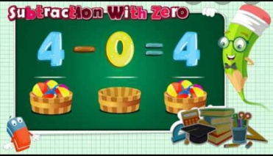  “what is the difference”,” how many are left”. These words indicate that a child has to remove or take away said number of things from the given group.
Learning Outcome | Children will create and solve subtraction word problems using pictures of objects, between the numbers 0 to 9.  - They will learn different methods used in subtraction.  - They will learn zero property.  - They will learn equal groups.  - By telling subtraction story sums, the concept is clearly understood.
Resources | Textbook: Let’s Discover Mathematics(CBSE) class 1  Web link: study.com  Education.com  Google
Can be integrated with other subjects? How? | Yes, it is used in our day-to-day life activities, like  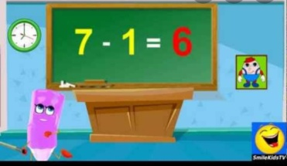  - After shopping, while giving and taking money from shop keeper.  - While counting the things we have.
Art integration | - Children will be given few straws, beats, pebbles to do subtraction sums, using numbers 0 to 9.  - A group of 5 to 10 children are made to stand in a circle. Then few children are called outside. Then remaining children have to count how many children are left in the circle.
Assessment Strategy | - Children will be assessed by giving flash cards ( few things drawn on it or numbers written on it) and asked to do subtraction sums.  - Work sheets will be given and answers will be checked.

****************************

JSS SHRI MANJUNATHESHAWARA CENTRAL SCHOOL – DHARWAD
LESSON PLAN 2020-21
STD 1 Subject: Mathematics
Chapter 5 Number [10 to 19]
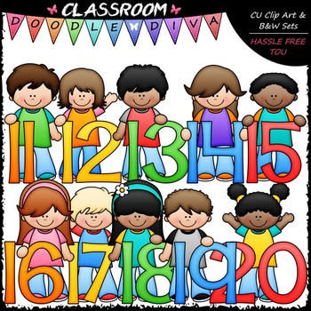

Month | August
Chapter | Numbers [10 to19 ]
Periods | 8
Contents | 5.1 Place of numbers 1 to 9.  5.2 One ten.  5.3 Introducing ones and tens.  5.4 Numbers 10 to 19.  5.5 Numbers 1 to 19 on abacus.  5.6 Before, after, and between.  5.7 Comparing and ordering.  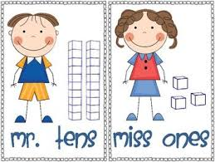  5.8 Addition / Subtraction.
Learner previous knowledge | Knowing numbers and number names, Enjoying numbers by saying number rhymes, Simple addition and subtraction.
Transaction Methodology | 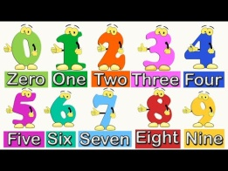  1. Teach counting with Number Rhymes.  2. Ask children to count the petals in flower.  3. Play number games using flash cards.  4. Point out the numbers on Vehicles number plate.  5. Write the number and make children to draw things that recognize the number given.
Activity tool | 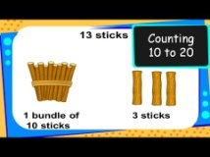  Prepare flash card from 10 to 19 and arrange them in ascending and descending order.  Using Ice cream children can do simple addition and subtraction.
Learning outcome | - Children are able tell the numbers and names  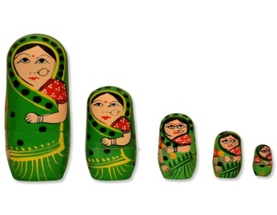  - Children arrange numbers in ascending and descending order.  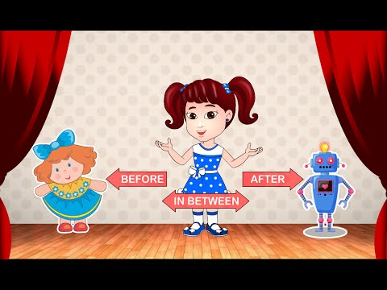  - They are able tell the numbers that come after, before and between.  - Children are able to recognize ones and tens.  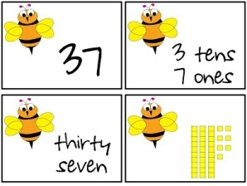  - Children are able to count and add numbers using abacus.  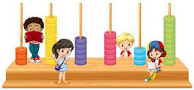
Resources | Text book : Let’s Discover Mathematics Class 1  Web link  http://www.mathsisfun.com/num
Can be integrated with other subjects? How? | Can be integrated to day to day life skills activities.  Can be integrated with Science.  - By counting leaves  - By counting petals of flower.
Art integration | 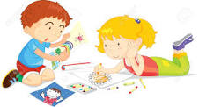  - Models of different types animals are given to children and made them to arrange them in order of ascending and descending.  - Draw the number of objects given.
Assessment Strategy | 1. Compare the numbers and circle the greater number.  2. Underline the number that is in ones place.  3. Identify the smallest and greatest number in the given flash card.  4. Compare the numbers using the symbol <, >, =.  5.Solve text book sums.

****************************

JSS SHRI MANJUNATHESHAWARA CENTRAL SCHOOL – DHARWAD
LESSON PLAN 2020-21
STD 1 Subject: Mathematics
Chapter 6 Number [20 to 99]
Month | September
Chapter | Numbers [20 to99 ]
Periods | 10
Contents | 6.1 How many tens?  6.2 Numbers 20 to 29.  6.3 Numbers 30 to 39.  6.4Numbers 40 to 49  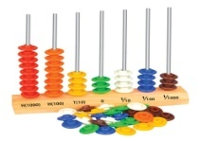  6.5 Numbers 50 to 59.  6.6 Numbers 60 to 69.  6.7 Numbers 70 to 79.  6.8 Numbers 80 to 89.  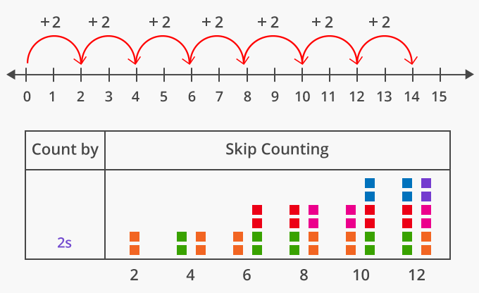  6.9 Numbers 90 to 99.  6.10 Numbers 20 to 99 on abacus.  6.11 Skip counting.  6.12 Numbers 1 to 99.
Learner previous knowledge | - Knowing the place value of numbers (ones and tens).  - Knowing the number names.  - To be able write the numbers from 1 to 100.
Transaction Methodology | Children will be told to refer text book and teacher will explain about each concept of ones and tens.  Teacher will explain the counting of numbers with ones and tens using abacus.  Using class room objects skip counting will be explained to the students.
Activity tool | Teacher will call 6 students and ask them to pick the numbers flash cards randomly and show it to the class and rest of the children will write the numbers in their book according to ascending and descending order.
Learning outcome | - Children are able to write numbers from 1 to 100.  - Children arrange numbers in ascending and descending order.  - Students are able write skip counting numbers of 2s, 5, 10s,....  - Children are able to do addition using ones and tens.  - Children are able to count and add numbers using abacus.
Resources | Text book : Let’s Discover Mathematics Class 1  Web link  http://www.mathsisfun.com/num
Can be integrated with other subjects? How? | Can be integrated to day to day life skills activities.  Can be integrated in sports.  - To identify the winners as first, second and third.
Art integration | 1. The bunches of pens and pencils are kept on the table and told to children to write how many tens and ones they can find.  2. Arrange the flash cards in order of descending.
Assessment Strategy | 1. Compare the numbers and tick the smaller number.  2. Write the skip counting of two’s till 20.  3. Solve text book sums.

****************************

JSS SHRI MANJUNATHESHWARA CENTRAL SCHOOL-DHARWAD
Lesson plan 2020-21

Std- 1 Subject- Mathematics.
CHAPTER -7 MEASUREMENT

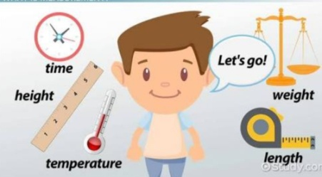
Month | September
Chapter | MEASUREMENT
Periods | 10
Content | 7.1 Long – Short  7.2 Tall – Short  7.3 Measuring length  7.4 Thick – Thin  7.5 Heavy – Light  7.6 Capacity
Learner’s previous knowledge | Few basic questions will be asked to know the previous knowledge of children, like  1. Who is tallest in the class?  2. What you say to fruit seller when you purchase apple?  3. Which city is very far from Dharwad?  4. Which is the heaviest animal?  Like this, the concept will be revised, what they have learnt in previous year. Then the lesson will be introduced to the children.
Transaction methodology | In this chapter children will learn how to measure the length, height, weight and capacity of the given object.  They will learn how to measure the length of class room, pencil, and other different things.  They will learn the new words like HANDSPAN, CUBIT AND FOOT SPAN, etc.
Activity/Tool | 1. Children will be described the meaning of measurement and the importance of measurement. They will enjoy measuring the length of class room by their footspan, table length by handspan and black board length by cubit.  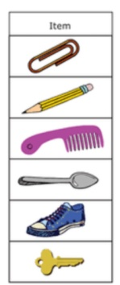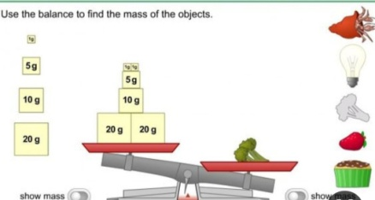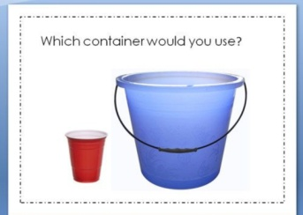  2. Children will be given few objects like water bottle, glass, water jug to measure their capacity.
Learning Outcome | Children will be able to explain the importance of measurement.  They will be able to measure the weight, length and capacity of given things.  They will be able to tell which thing is taller and which is shorter and which is thicker and which is thinner.  They will be able to tell which thing is heavier and which is lighter and whose capacity is more…. Like that.  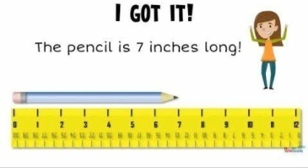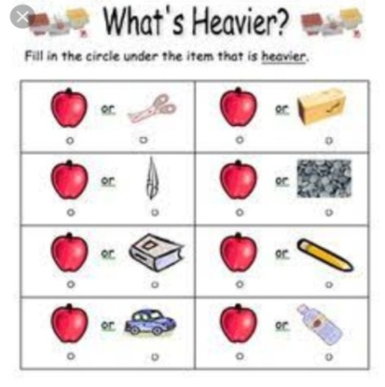
Resources | Textbook: Let’s Discover Mathematics(CBSE) class 1  Web link: study.com  Education.com  Google
Can be integrated with other subjects? How? | Yes, it is used in our day-to-day life activities, like  - In comparing the height of different things  - To know the length of roms and many other things  While purchasing things in shop, to tell the quantity.  - While measuring the capacity of containers, etc. 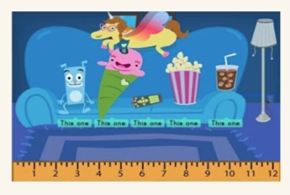
Art integration | Students will get plenty of practices to measure the length, width, weight, capacity of different things available to them.  They will enjoy these Fun hands-on activities.  They are asked to measure the length of the class room, length of the book, capacity of water bottle, weight of different things.  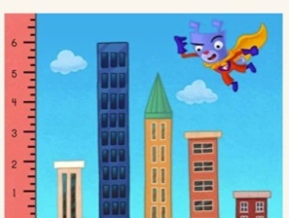
Assessment Strategy | In pairs, students will estimate the measurement of items in the class room, students will then move around the room measuring different objects or area in the class room using the handspan, cubit and foot span. Then they will tell to the teacher about the measurement of the things, which they have measured.  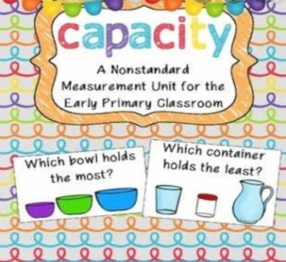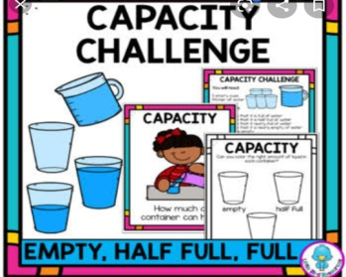

***************************
JSS SHRI MANJUNATHESHWARA CENTRAL SCHOOL-DHARWAD
Lesson plan 2020-21

Std- 1 Subject- Mathematics.
CHAPTER 8 Shapes
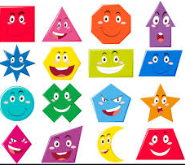

Month | October
Chapter | Shapes
Periods | 8
Content | 1. Different shapes.  2. Solid Figures.  3. Rolling and sliding.
Pre-requisite (KNOWLEDGE) | 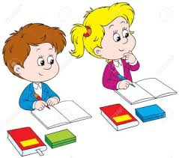  Knowing basic shapes Square, circle, triangle  and oval shape.
Transaction Methodology | Children were told to observe the shapes of all things they eat. Group discussion was done on the same. They came up with telling all the shapes of biscuits, corn, pizza, cake etc……
Activity /Tool | 1. Flash cards of different shapes.  2. Prepare the shapes from the shape craft sheet. Cut out the shapes from the sheet, for each group all set of shapes will be there. Children will be told to prepare a house/face using all the shapes.  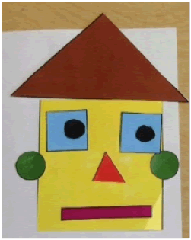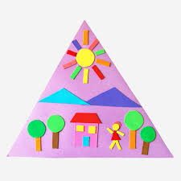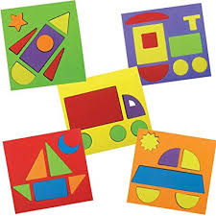
Learning Outcome | Children will be able to recognize different shapes
Resources | Textbook: Let’s Discover Mathematics(CBSE) class 1  Web link: https://www.eslkidstuff.com
Can be integrated with other subjects? How? | Yes, can be integrated with science for learning different shapes of flowers, seeds, animals etc.  Can be integrated with Life Skills day-to-day life
Art integration | 1. Children were told to do craft activity with using the different shapes.  2. Children were told to use ice-cream sticks/ear buds and make different shapes joining them.  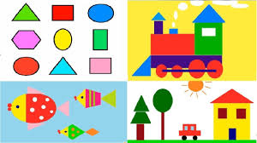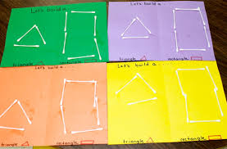  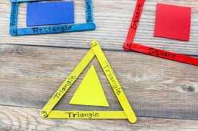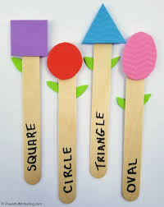
Assessment Strategy | Playing missing shapes  Spreading the shapes out on the floor and gather everyone around. Tell everyone to close their eyes. Teacher will take away one shape and say “Open your eyes”. Everyone must guess which shape is missing.  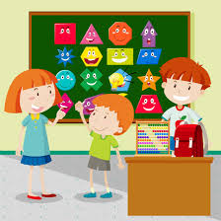

****************************************

JSS SHRI MANJUNATHESHWARA CENTRAL SCHOOL-DHARWAD
Lesson plan 2020-21

Std- 1 Subject- Mathematics.
CHAPTER 9 Money

Month | October
Chapter | Money
Periods | 8
Content | Money
Pre-requisite (KNOWLEDGE) | Few questions will be asked to know the previous knowledge like  1. When they go to shop to buy chocolates, what do they give to shopkeeper?  2When they buy the toys what do they give in return to the shopkeeper?
Transaction Methodology | ‘Pick and speak’  Topic will be market, shopping, vegetables, etc……  Interaction between teacher and students  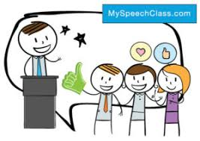  Money will be introduced in the discussion.
Activity /Tool | Setting up a fun pretending to shop at a store that teacher has set up in classroom or at home. With some items ready for children to purchase including homemade price tags and fake money for them to use.  Asking students to think about times in their life they have received money. Students talk about birthday, festivals or holiday gifts. They may also mention allowances.  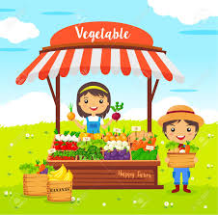
Learning Outcome | Identification of currency( coins and Notes)  Students will be able to exchange sufficient rupees for goods.
Resources | Textbook: Let’s Discover Mathematics(CBSE) class 1  Web link: https://www.education.com
Can be integrated with other subjects? How? | Can be integrated to life skills-day -to-day life.  Can be integrated to addition and subtraction.
Art integration | Fun craft activity, students design and "make" their own money, for use as rupee. Putting the faces of family members and pets on the notes makes a fun reflection of the family members.  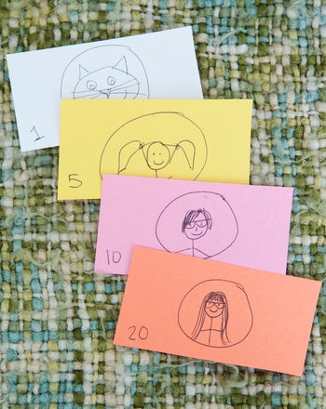
Assessment Strategy | Pairing the students into groups of two or three. Telling the students that they will be working to come up with at least two different note combinations that add up to make twenty rupee using duplicate notes.  ( duplicate notes will be provided by the teacher)

*******************************

JSS SHRI MANJUNATHESHWARA CENTRAL SCHOOL-DHARWAD
Lesson plan 2020-21

Std- 1 Subject- Mathematics.
CHAPTER – 10. TIME
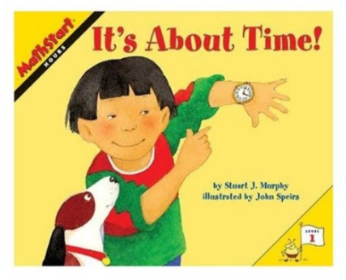
Month | December
Chapter | TIME
Periods | 9
Content | - Earlier – Later  - Days of the week  - Months of the year  - Long and short duration
Learner’s previous knowledge | Few basic questions will be asked to know the previous knowledge of children, like  - What you do AFTER getting up in the morning?  - What you do BEFORE going to sleep in the night?  - Every week on which day there will be holiday to school?  - Which month we will be having summer vacation holidays?  Like this, the concept will be introduced.
Transaction methodology | The concept of TIME- Earlier and Later will be cleared to children  They will learn the days of the week, months of the year and the duration like short – duration and long- duration concept will be made clear.  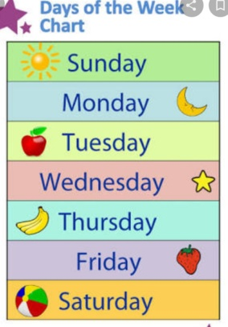
Activity/Tool | Children will learn the time by saying their activities like what they do at particular time. They will tell the days of the week. They will learn months of the year.  By saying few activities, will ask whether that activity is done before or after the particular activity.  By asking which day comes after which day or which day comes before which day,  Like this activities are done.
Learning Outcome | Children will be able to tell  - At what time they do particular activities.  - Day of the week  - Months of the year.  - Time duration. Etc
Resources | Textbook: Let’s Discover Mathematics(CBSE) class 1  Web link: study.com  Education.com  Google
Can be integrated with other subjects? How? | 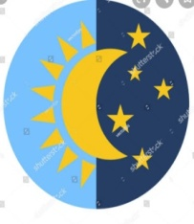  Yes, it is used in our day-to-day life activities, like  - At what time they have to go to school?  - Which month their school starts?  - Which month they will be having summer  Holidays?  - Which activity or work takes long or short duration of time?
Art integration | 1. Children will be shown few flash cards with some activity pictures on it and asked to tell at what time they will be doing.  2. Children are made to stand one after the other and given the names of days. And asked who is after or before they said day.
Assessment Strategy | 1. Children will assessed by asking question on week day’s name, months name etc.  2. They will be given flash cards and worksheet with questions on it.
***************************************

SRI MANJUNATHESHAWARA CENTRAL SCHOOL – DHARWAD
LESSON PLAN 2020-21
STD 1 Subject: Mathematics
Chapter 11 DATA HANDLING
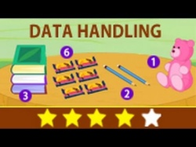

Month | November
Chapter | Data Handling
Periods | 8
Contents | Classification
Learner previous knowledge | Arranging the things according to same shape, size and colour.  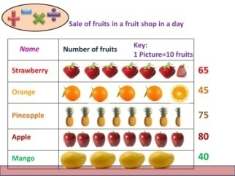
Transaction Methodology | Children were made to learn, to segregate the things according to their size, shape and colour.
Activity tool | 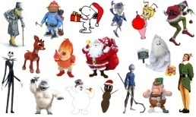  Few things play things are jumbled and given to group of children and will ask to arrange the things that look like same.
Learning outcome | - Children are able to identify the names of the things.  - They are able to identify the colours of the things.  - They notice to what group the objects belongs to?.
Resources | Text book : Let’s Discover Mathematics Class 1  Web link  http://www.mathsisfun.com/num
Can be integrated with other subjects? How? | Can be integrated to day to day life skills activities.  Can be integrated with Science.  - To identify group of animals.  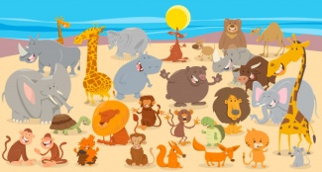  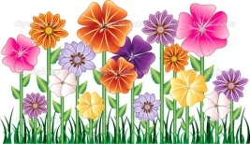  - To identify flowers and plants.
Art integration | 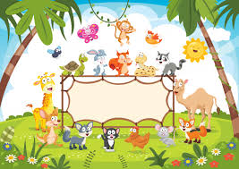  Nature scenery with animals, plants picture will be given and children have to group same kind of animals, plants and so on.
Assessment Strategy | - Collect different solid shapes such as pebbles, boxes, balls, cones, etc. having different colours. Then sort these objects based on their shape, colour and size.

****************************

JSS SHRI MANJUNATHESHWARA CENTRAL SCHOOL-DHARWAD
Lesson plan 2020-21

Std- 1 Subject- Mathematics.
CHAPTER 12 Patterns.
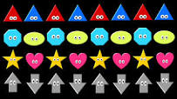

Month | December
Chapter | Patterns
Periods | 8
Content | Patterns
Pre-requisite (KNOWLEDGE) | Arranging the alphabets and numbers according to the sequence.
Transaction Methodology | Group discussion  Children will be asked how the numbers and alphabets are arranged; teacher tells there is a pattern to be followed.  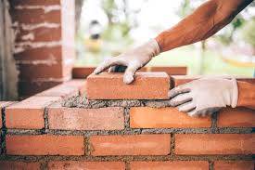  Ask children if they have seen a mason building a wall how will he arrange the bricks, he will be following specific pattern to arrange them.
Activity /Tool | Blocks  Block games was played to make children understand the concept of pattern.  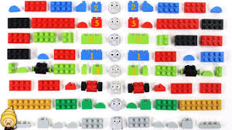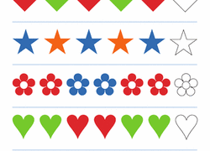
Learning Outcome | Students will be able to produce and extend a pattern using different objects
Resources | Textbook: Let’s Discover Mathematics(CBSE) class 1  Web link: https://www.education.com
Can be integrated with other subjects? How? | Can be integrated to life skills-day -to-day life.  Can be integrated to science.
Art integration | Children will be given activity to draw different pictures in a pattern.  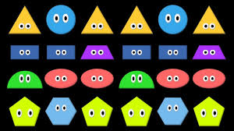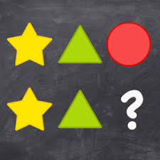
Assessment Strategy | Assessment will be done based on the children completing the activities and worksheets will be given.  Children will be told to drawing on the board few examples like two balls, one bat again two balls, one bat; one triangle, one square and a circle.

******************************

